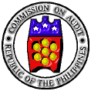

Republic of the Philippines
COMMISSION ON AUDIT

Commonwealth Avenue, Quezon City

ANNUAL AUDIT REPORT

on the

NATIONAL ELECTRIFICATION

ADMINISTRATION

For the Years Ended December 31, 2019 and 2018

